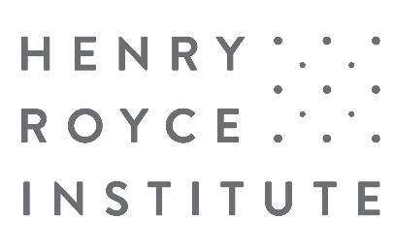

Royce Industrial Collaboration Programme Application Form
Accelerating Industry towards a sustainable net-zero future

Before completing this application form, please ensure you registered your interest and had a preliminary conversation with a Research and Business Engagement (RBE) Manager in the Royce team.

Applications exceeding the word limit may be rejected.

Please provide the name of the RBE Manager you engaged with as a part of your pre-submission discussions:
RBE Manager name

- Project title and duration
Title | Start date | End date

- Collaboration Details

  - Royce Lead Partner details (expand as necessary)
Partner name
Address (incl. postcode)
Contact Name
Position
Email Address

  - Collaborating organisation(s) details (expand as necessary)
Organisation name
Address (incl. postcode)
Contact Name
Position
Email Address
Type of organisation (Microbusiness/SME/Large Enterprise/RTO)

  - Collaborating organisation(s) (expand as necessary): Please provide a brief description of your organisation (Sector; Products; Markets etc..)

  - Project team (budget holder must be a Royce partner)
Name | Organisation | Role | Email
 |  | Royce Lead
 |  | Industrial Lead
 |  | RTO Lead

- Project Details
  - Project summary
Project description
Please provide a description of the project you wish to undertake. This should include a summary of what the project aims to investigate and why this is novel, important, and timely. (max. 600 words)

Explain what Royce capability is required for this work, including a brief justification. (max. 300 words)

Describe why this team is the best position to deliver this project. (max. 300 words)

Please list the outputs expected to arise from the project along with the envisaged longer-term outcomes. (max. 250 words)

Project resources and management
Provide a breakdown of the expected total cost of your project along with any cash or in-kind contributions using the form provided (further information about payment schedule will be provided to successful applicants)

NB – Projects will be funded on the basis of up to 80% FEC and will be awarded to the host Royce Partner. The Research and Business Development Manager from the Royce Partner/s you are discussing your application with can help you complete this section. It should include all eligible costs as described in the application information.

Provide an outline of how you intend to deliver your project, including discussion of resource availability and identification of the main risks. (max. 300 words)

  - Project Outcomes and Impact
Expected follow-on activities
How will the success of the project will be measured within 12 months and what follow-on outcomes are envisaged. (max. 150 words)

Expected impact
Describe the expected impact of the project in relation to the ‘accelerating industry towards a sustainable, net zero future’ goal, as well as any wider benefits. (max. 300 words)

Define the potential value to your organisation (in commercial terms) and value to the wider materials community of successfully completing the project. (max. 300 words)

It is an expectation that companies successful in applying to the scheme will work with Royce to produce publicly available case studies (commercially sensitive information notwithstanding) to highlight the types of projects which are routinely undertaken and which produce a positive outcome for both the company and Royce.

Applications that are rejected or unsuccessful will be permanently deleted following notification to the applicant of either outcome. Successful applications will be stored at the respective Royce partner in electronic format until such time that the project is completed at which point the applicant can determine what should happen to the information contained within.

